Question 1

Table fields:

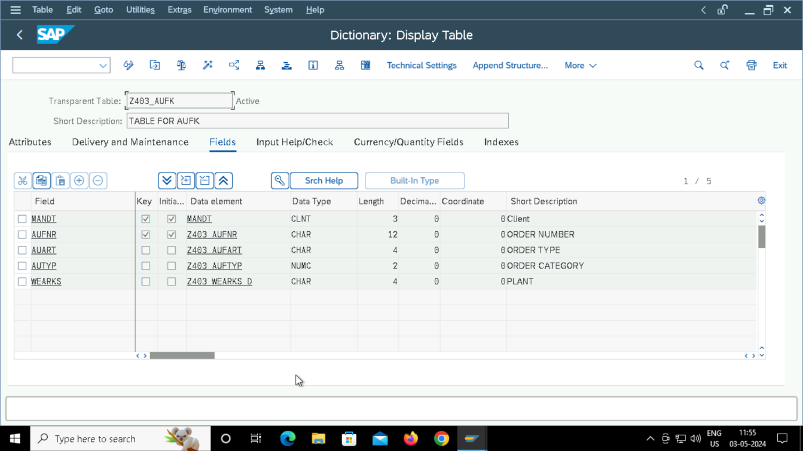

Records output:

TMG:

